

Ref: 2645/Circular/03.10

1 March 2010

All Residents
No.9, 11,15 Ardmore Park, Singapore

Dear Residents,

SERVICING SCHEDULE FOR THE MONTH OF MARCH 2010

Please be informed of the following servicing schedules for the lifts/fire protection system/pest control/recycling for the month of
MARCH 2010.

S/No | Contractor | Services | Date | Time | Remarks
1 | B.S. Engineering Co Pte Ltd | Fire Protection | 24 March 2010 | 1300hrs to 1700hrs | Please do not be alarmed when the fire alarm is activated
2 | ABJ Pest Control Pte Ltd | Pest Control | 4, 11, 18 & 25 March 2010 | Between 0930hrs to 1200hrs | Please close (seal) your bin chute hopper and windows tightly during the fumigation
3 | In-house | Collection of Recycle Materials | Daily | From 0800hrs to 0930hrs | Please place recyclable materials besides the service lift area for collection.
4. | Anchor Cleaning Agency Pte Ltd | Bin Chute Flushing | 3, 6, 10, 13, 17, 20, 24, 27 & 31 March 2010  (Every Wed & Sat) | From 1000hrs to 1200hrs | Please close your bin chute hopper during the flushing

Lift Maintenance Schedule
Blk No | Lift No | Date | Time | Remarks
Block 9 | Lobby Lift No 1  Lobby Lift No 2  Lobby Lift No 3  Lobby Lift No 4  Service Lobby Lift No 10 | 16 March 2010  16 March 2010  16 March 2010  16 March 2010  16 March 2010 | 1000hrs to 1100hrs  1100hrs to 1200hrs  1300hrs to 1400hrs  1400hrs to 1500hrs  1500hrs to 1600hrs | Kindly be reminded to bring along your rear door key during this period
Block 11 | Lobby Lift No 5  Lobby Lift No 6  Lobby Lift No 7  Lobby Lift No 8  Service Lobby Lift No 11 | 17 March 2010  17 March 2010  17 March 2010  17 March 2010  17 March 2010 | 0900hrs to 1130hrs  1130hrs to 1230hrs  1500hrs to 1600hrs  1230hrs to 1500hrs  1600hrs to 1700hrs | Kindly be reminded to bring along your rear door key during this period
Block 13 | Club House P1 | 18 March 2010 | 1130hrs to 1230hrs
Block 15 | Lobby Lift No 9  Lobby Lift No 10  Lobby Lift No 11  Lobby Lift No 12  Service Lobby Lift No 12 | 18 March 2010  18 March 2010  18 March 2010  18 March 2010  18 March 2010 | 0900hrs to 1130hrs  1500hrs to 1600hrs  1600hrs to 1700hrs  1230hrs to 1500hrs  1700hrs to 1800hrs | Kindly be reminded to bring along your rear door key during this period

Weekly high-level dusting and cleaning of the private lift cars schedule:
Day of Cleaning | Time | Block /Lift Nos. | Remarks
Monday  Tuesday  Wednesday | 10.00 am to 11.00 am  11.00 am to 12.00 pm  10.00 am to 11.00 am  11.00 am to 12.00 pm  10.00 am to 11.00 am  11.00 am to 12.00 pm | Blk 9/ Lift 1 & 2  Blk 9/ Lift 3 & 4  Blk 11/ Lift 5 & 6  Blk 11/ Lift 7 & 8  Blk 15/ Lift 9 & 10  Blk 15/ Lift 11 & 12 | Please do not be alarmed if you find a cleaner in the private lift during these times.

If you have any queries, please feel free to contact us at the management office telephone number 6733 0862. We apologise for any inconvenience caused.

Yours Faithfully,

Knight Frank Estate Management Pte Ltd
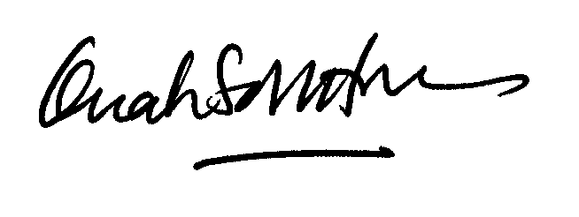

Ms Quah Soh Hoon
Ardmore Park General Manager
For and on behalf of The MCST Plan No. 2645

